**Project Planning Phase**

**Project Planning Template (Product Backlog, Sprint Planning, Stories, Story points)**

|  |  |
| --- | --- |
| Date | 18 October 2022 |
| Team ID | PNT2022TMID10208 |
| Project Name | Project - IOT Based Safety Gadget for Child Safety  Monitoring&Notification |
| Maximum Marks | 8 Marks |

**Product Backlog, Sprint Schedule, and Estimation (4 Marks)**

Product backlog and sprint schedule

| **Sprint** | **Functional Requirement (Epic)** | **User Story Number** | **User Story / Task** | **Story Points** | **Priority** | **Team Members** |
| --- | --- | --- | --- | --- | --- | --- |
| Sprint-1 | Registration | USN-1 | As a user, I can register for the application by entering my email, and password, and confirming my password. | 4 | High | SUDHA |
| Sprint-1 | Confirmation Email | USN-2 | As a user, I will receive a confirmation email once I have registered for the application | 4 | High | SWVATHALAKA |
| Sprint-1 | Authentication | USN-3 | As a user, I can register for the application through Gmail and mobileapp. | 4 | Medium | SUSMITHA |
| Sprint-1 | Login | USN-4 | As a user, I can log into the application by  entering email & password | 4 | High | SUBAASRI |
| Sprint-1 | Dashboard | USN-5 | As a user, I need to be able to view the  functions that I can perform | 4 | High | SUDHA |
| Sprint-2 | Notification | USN-1 | As a user, I should be able to notify my parent and guardian in emergency situations | 10 | High | SUDHA |
| Sprint-2 | Store data | USN-1 | As a user, I need to continuously store my location data into the database. | 10 | Medium | SUSMITHA |
| Sprint-3 | Communication | USN-1,2 | As a user, I should be able to communicate with my parents | 6 | Low | SUSMITHA,SUBAASRI |
| Sprint-3 | IOT Device – Watson  communication | USN-1,3 | The data from IOT device should reach IBM Cloud | 7 | Medium | SWVATHALAKA,SUDHA |
| Sprint-3 | Node RED- Cloudant  DB communication | USN-1,4 | The data stored in IBM Cloud should be  properly integrated with Cloudant DB | 7 | High | SUDHA,SUSMITHA |
| Sprint-4 | User – WebUI  interface | USN-1,5 | The Web UI should get inputs from the user | 10 | High | SUBAASRI,SWVATHALAKA |
| Sprint-4 | Geofencing | USN-1,2,5 | The geofencing of the child should be done based on the geographicalcoordinates | 10 | High | SUDHA,SWVATHALAKA,  SUSMITHA,SUBAASRI |

**Project Tracker, Velocity & Burndown Chart: (4 Marks)**

| **Sprint** | **Total Story Points** | **Duration** | **Sprint Start Date** | **Sprint End Date (Planned)** | **Story Points Completed (as on Planned End Date)** | **Sprint Release Date (Actual)** |
| --- | --- | --- | --- | --- | --- | --- |
| Sprint-1 | 20 | 6 Days | 24 Oct 2022 | 29 Oct 2022 | 20 | 29 Oct 2022 |
| Sprint-2 | 20 | 6 Days | 31 Oct 2022 | 05 Nov 2022 | 20 | 05 Nov 2022 |
| Sprint-3 | 20 | 6 Days | 07 Nov 2022 | 12 Nov 2022 | 20 | 12 Nov 2022 |
| Sprint-4 | 20 | 6 Days | 14 Nov 2022 | 19 Nov 2022 | 20 | 19 Nov 2022 |

**Velocity:**

Imagine we have a 10-day sprint duration, and the velocity of the team is 20 (points per sprint). Let’s calculate the team’s average velocity (AV) per iteration unit (story points per day)



|  |  |
| --- | --- |
| SPRINTS | AV |
| SPRINT-1 | 20/6=3.33 |
| SPRINT-2 | 20/6=3.33 |
| SPRINT-3 | 20/6=3.33 |
| SPRINT-4 | 20/6=3.33 |

**MILESTONE:**

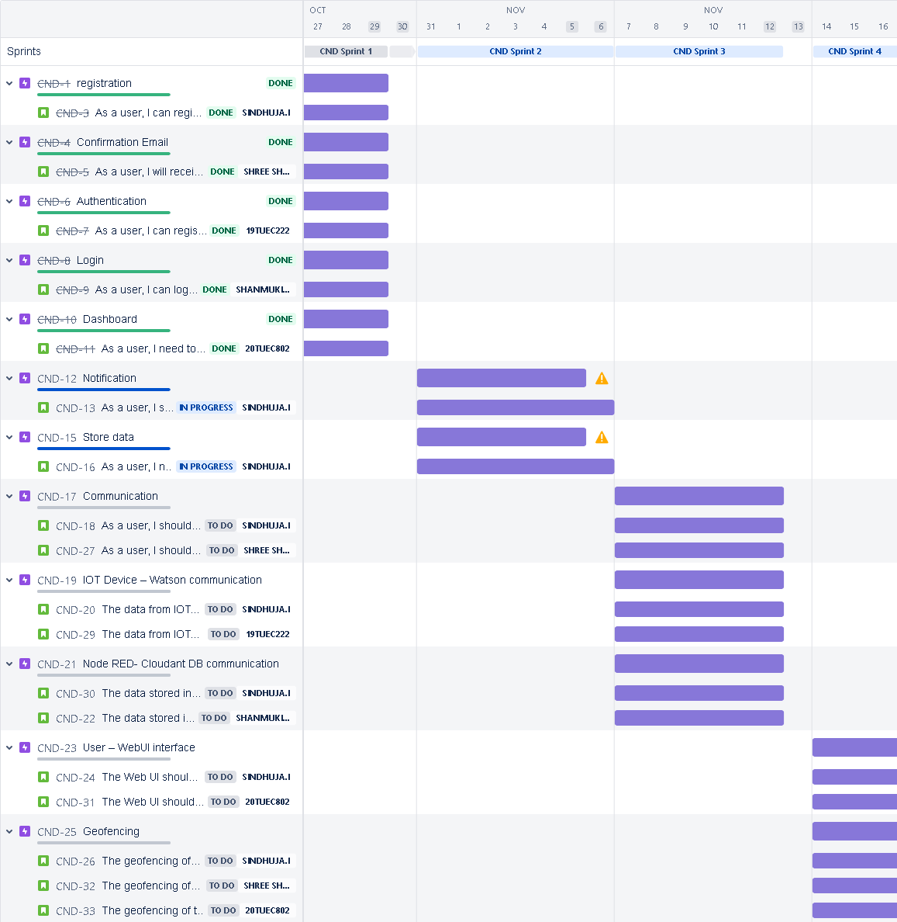

**Burndown Chart:**

A burn down chart is a graphical representation of work left to do versus time. It is often used in agile[software development](https://www.visual-paradigm.com/scrum/what-is-agile-software-development/) methodologies such as [Scrum](https://www.visual-paradigm.com/scrum/scrum-in-3-minutes/). However, burn down charts can be applied to any project containing measurable progress over time.